To: | Scrutiny Committee
Date: | 14 January 2020
Report of: | Tim Sadler, Transition Director
Title of Report: | Go Ultra Low Oxford Pilot – On-street & Taxi

Summary and recommendations
Purpose of report: |  | The scrutiny committee asked for a report to consider the outcomes of the Go Ultra Low Oxford Pilot Stages.
Key decision: |  | No
Executive Board Member: |  | Councillor Tom Hayes, Cabinet Member for Zero Carbon Oxford
Corporate Priority: |  | Clean Green Oxford
Policy Framework: |  | Clean Air Act
Recommendation:That the Scrutiny Committee resolves to:
1. | Note and comment on the report

Appendices
Appendix 1 | TSU - Final Report GULO Phase 1
Appendix 2 | TSU – GULO Policy Brief
Appendix 3 | CENEX ULEV Hackney Carriage Business Model Assessment
Appendix 4 | EST Taxi Feasibility Study.

Abbreviations:
- CENEX – Centre of Excellence for Low Carbon and Fuel Cell Technologies
- EV – Electric Vehicle
- GULO – GO Ultra Low Oxford
- ODS – Oxford Direct Services
- OLEV – Office for Low Emission Vehicles
- ZEZ – Zero Emission Zone

Introduction and background
- Oxfordshire County Council’s Local Transport Plan 4, published in 2015, set out proposals to introduce a Zero Emission Zone (ZEZ) in Oxford starting in 2020. Since then proposals have been developed by Oxford City Council, in partnership with Oxfordshire County Council, for a ZEZ in Oxford, to be rolled out in phases starting in 2020. The overall aim of this journey to zero is to eliminate transport ‘tailpipe’ emissions in Oxford city centre by 2035. Transitioning businesses and residents to ultra low and zero emission vehicles is a critical building block of this zero emission ambition.

- Action is required because there is no ‘safe’ level of air pollution. A 2016 report from the Royal College of Physicians and the Royal College of Paediatrics and Child Health found that outside air pollution cuts short 40,000 lives a year in the UK. Transport is by far the most significant source of emissions of oxides of nitrogen (NOx) in Oxford, accounting for 75% of emissions.

- A 2016 feasibility study commissioned by Oxford City Council, conducted by the Energy Savings Trust, established that the Oxford Hackney Carriage produces comparatively high levels of NOX emissions, driven by the fleet’s age profile – at the time of study, over 50% of vehicles were 17 years or older, all were diesel and only one vehicle met the newest Euro6 standard. A second study conducted by CENEX commissioned by Oxford City Council using telematics showed routing patterns in the current fleet, which confirmed that taxi NOx emissions are largely generated within the central, high footfall areas of Oxford.

- New emissions requirements for hackney carriages were agreed in February 2019 with the support of the trade: Citywide Hackney Carriages emissions standards will apply from 2020, with a requirement for all vehicles to be ULEV by 2025. These are the toughest environmental requirements on Hackney Carriages in the country.

- Oxford’s first Ultra Low Emission Taxi, and two zero emission Private Hire Vehicles have since been licensed in Oxford, and the City Council is working informally and informally with drivers and the Hackney Carriage trade to increase uptake.

- In July 2018 the Government launched its “Road To Zero” strategy, setting out its ambition to see at least half and as many of 70% of new cars to be ultra low emission by 2030. The Government is committed to a ban on the sale of all new polluting vehicles from 2040—this Council has called for this to be brought forward to 2030 at the latest via the Oxford Charter for Cleaner Air, signed by other local councils.

- Home charging, mostly overnight, is the most popular way to charge an electric vehicle, and by far the cheapest, with overnight cost as low as 5p per kwh on private tariffs, compared to rapid charging costing as much as 35p per kwh. Public on-street charging is a form of home charging, doubling up as destination charging in the day time.

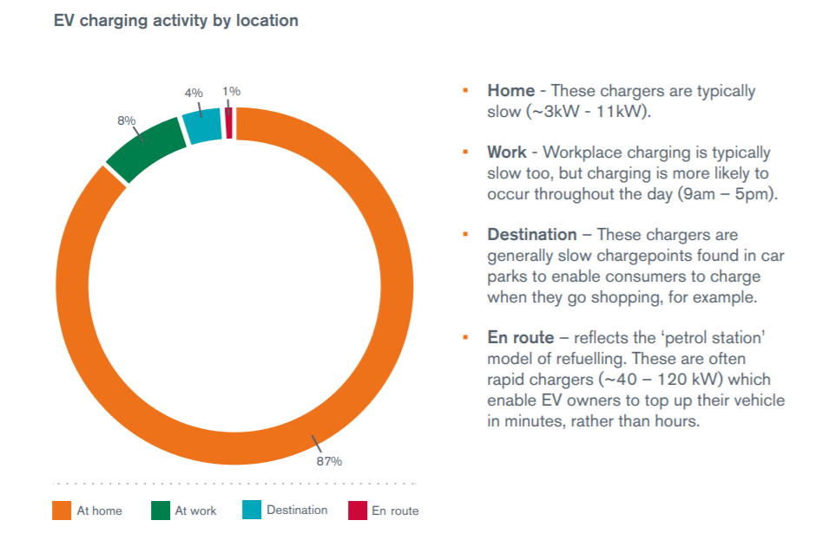

- EV uptake is anticipated to grow exponentially, with uptake slow initially from a very low starting point, and then accelerating. Lack of availability of rapid charging facilities is indicated to be a barrier for all EV uptake, lack of slow and fast public charging solutions are a strong barrier for EV uptake for residents without access to off-street parking.

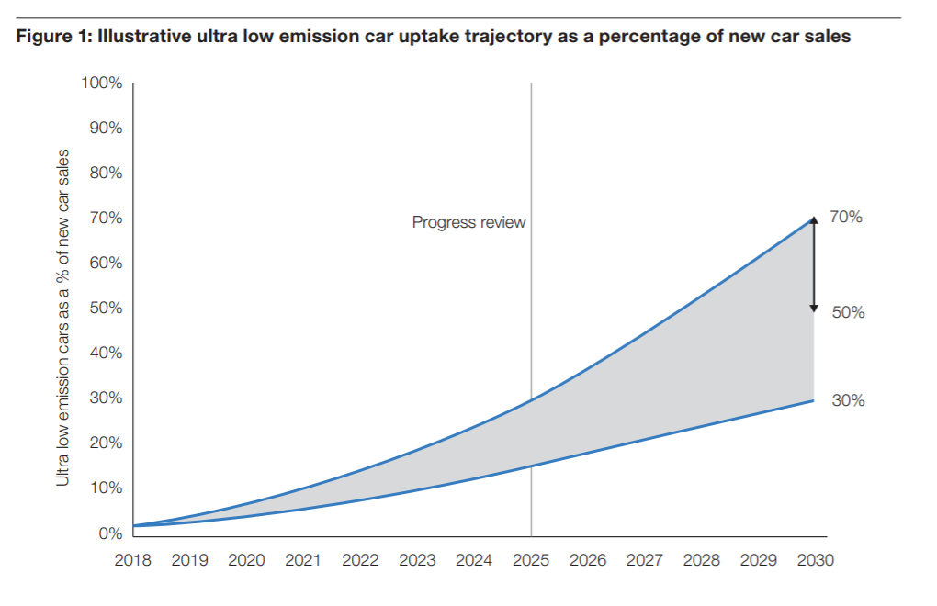
- Based on recently published DVLA data, the uptake of electric vehicles in Oxford is double that of the national mean, with its demographic presenting many characteristics of EV Early Adopters elsewhere. However, 28% of Oxford Homes are terraced, with no off-street parking. This makes it a challenge for many residents to transition to EV, even where there is demand, particularly in inner city areas.

Go Ultra Low City Programme and Approach
- Go Ultra Low Cities Grants: To support the EV transition required to achieve the outcomes pursued through the ZEZ, Oxford City Council successfully applied for two grants under the Go Ultra Low Cities programme, funded by the Office for Low Emission Vehicles (OLEV): GULO Taxi and GULO On-street, totalling £373000 and £800000 respectively, funding up to 19 fast and rapid taxi charge points that allow a vehicle to charge up to 80% in under an hour, and up to 130 on-street charging solutions.

- Piloting approach: Both GULO Taxi and GULO On-street are being delivered in two phases, a Pilot phase, now completed, and a Roll Out phase, commencing in 2020/21. The purpose of the piloting approach is to ensure that we identify the best solutions for the city proactively and apply these learnings at scale during the roll out.

- Pilot stage charge point delivery was driven by availability of volunteers willing to purchase an EV vehicle, and feasibility of locations, with an effort being made to recruit pilot participants in the less advantaged areas of the city. Demand planning and resident engagement approach will be revisited as part of the roll-out stage, to ensure benefits are delivered fairly across the city.

- Charge points delivered: Pilot charging installations have been delivered and evaluated for both projects, delivering 4 rapid charge points for Oxford licensed Ultra Low Emission (ULEV) taxis and private hire vehicles at Manzil Way, and 43 charge points for Oxford Residents without access to off-street parking. The higher number of chargers in OX2 and OX4 is driven by availability of volunteers and their willingness to trial lamp post chargers, which are cheaper to install and not usually accompanied by EV parking bays, so require a denser application than bollard-style chargers.

GULO Onstreet: | Chargers | Charge points | Locations
OX1 | 3 | 5 | 3
OX2 | 21 | 23 | 13
OX3 | 4 | 5 | 4
OX4 | 8 | 10 | 8
Grand Total | 39 | 43 | 28

Go Ultra Low Oxford (GULO) Taxi

GULO Taxi Benefits and Progress:

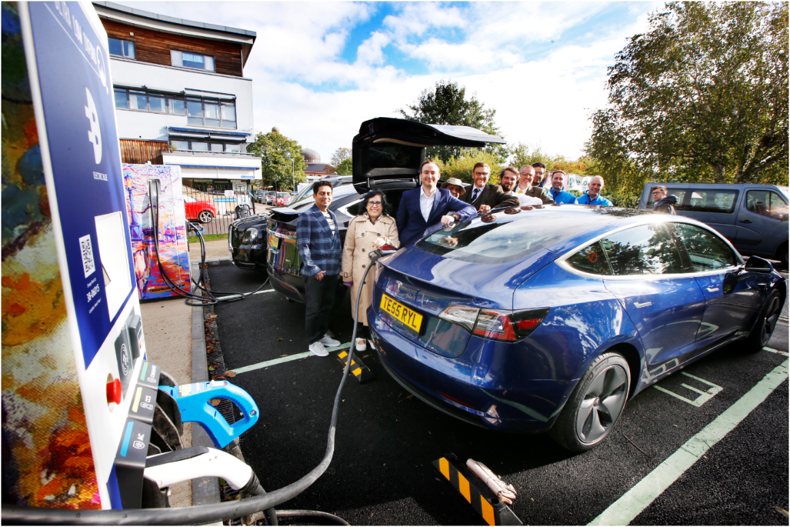
- GULO Taxi Rapid pilot: A high profile flagship rapid taxi charging site consisting of two chargers (four charge points) has been successfully delivered in Oxford at Manzil Way Gardens as part of that area’s larger redesign on the 16th of October, and has been positively received by the trade. The chargers seek to highlight the scenery of their location and prevent unwanted graffiti with street art created by a local artist.

- Licensing fee support: Available for the first 10 early adopters of ULEV taxis and private hire vehicles, each valued at up to £3k. (Funded by UK Innovate through Energy Superhub Funding (ESO)). One Hackney Carriage (HCV) and two Private Hire vehicles (PHV) are currently registered with the scheme.
Interested HCV and PHV owners can express their interest in the scheme at AirQuality@oxford.gov.uk.

- Engagement events and workshops: Four delivered and well received, aim to inform, and build capacity and change resilience. Fifth event planned Feb19.

- Regular, bi-monthly engagement meetings with the Hackney Trade association.

- Duty Cycle Assessment: We are working with Hackney drivers to offer duty cycle assessments, which compare their costs of running diesel vehicles with the potential cost of electric hackneys and provide drivers with personalised reports (Funded by UK Innovate through Energy Superhub Funding (ESO))

- Try Before You Buy’ programme (until 2023) for Hackney drivers which allows them to test drive electric hackney carriages for up to 4 weeks to familiarise themselves with the vehicles, their capabilities and running cost. (Funded by UK Innovate through Energy Superhub funding (ESO))

- ODS EV servicing: Oxford Direct Services, Oxford City Council’s TEKAL company is an certified service centre for all electric vehicles including being an approved authorised service dealer for the electric LEVC TX taxis and has built its EV repair capabilities by training staff and investing in the appropriate diagnostic and specialist insulated tools required to keep electric taxis and other EVs on the road.

GULO TAXI Next Steps:
- GULO Taxi Rapid Chargers Roll-Out: The council is currently procuring for a contractor to deliver the remaining charge points under the GULO Taxi scheme over the course of the next financial year, with locations to be determined by mid 2020 and the project fully delivered in 2021/22. The successful supplier will deliver feasibility, installations and operations delivered as a turnkey solution.

Go Ultra Low Oxford On-Street

GULO ON-STREET Benefits and Progress:
- Active On-street Charging Sites: 28 charge point sites are in active operation across the city, consisting of Lamp post chargers, Bollard chargers and Cable Channels.

- TSU report: Oxford University’s Transport Studies Unit (TSU) supports the GULO On-street pilot monitoring and evaluation work package. The TSU published a final report on the GULO pilot project recently, which was preceded by two interim reports. The report and its findings will inform the roll-out phase two of the project. (see also Appendix 1 – Final Report GULO Phase 1)

- Local Authority Outreach programme: Oxford has delivered events designed to facilitate learning across Local Authorities actively delivering EV infrastructure (eg. GULO ASPE event Dec 2018, GULO Cities event July 2019).

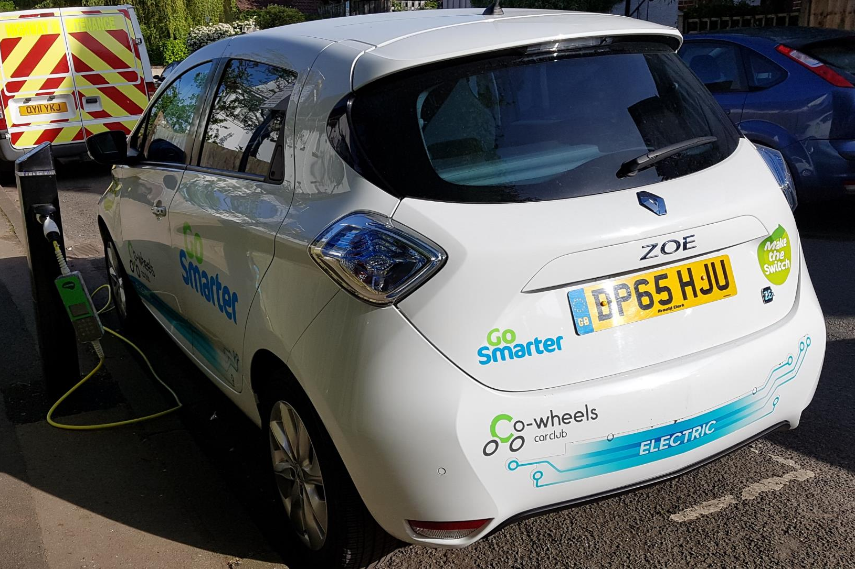
- Electric Car Clubs 9 electric car club vehicles have been delivered under GULO in Oxford in partnership with the social enterprise Co-Wheels, with further expansion planned for 2020.

- GULO On-street Demand planning: Residents who would like their street to be considered for an electric charging point in the roll out phase can contact the Council with an expression of interest, to be recorded on an internal demand tracker. All expression of interest locations will be considered for possible roll-out locations.

- Large Scale Resident Engagement: Three mass resident engagement events were delivered alongside the GULO programme annually: a test drive event at Blenheim Palace in 2017, a full day EV event on Broad Street in 2018 as part of Green Week, repeated in 2019 with a footfall of 20000 visitors.

- A quarterly EV business breakfast, reaching 100 members of the local business community per sitting, now successfully delivered in partnership with Green Tech. Engaging residents associations, logistics companies, landowners etc. around EV themes, and building capacity in the local economy for employers to support the EV transition.

- EV Summits: Now two established annual events with international reach, One focussing on E-bikes, one (entering its third year) on electric cars, vans and other vehicles, delivered in partnership with Green TV. Brings together business leaders and key players working on electric vehicles, energy, information technology, policy and charging infrastructure, to explore how to advance full, battery electric, eMobility.

GULO ON-STREET Next Steps:

- GULO On-street Full Roll out: Pilot phase project review and close down commencing January 2020, Roll-Out stage delivering remaining up to 100 charge points to follow 2020/21. A framework approach might be considered to extend the scheme in terms of number of chargers further, and resident engagement and demand planning will form a discreet work package.

- EV Charging Planning Guidance: Supporting local building sector to deliver better charging solutions, by producing and making available a technical advice note (TAN) on EV infrastructure, supported by the Energy Saving Trust.

- Super Rapid Charging Hub: Energy Superhub Oxford (ESO, UK Innovate funded) will enable the establishment of an electric vehicle ‘superhub’ – which aims to be the first charging hub in Oxford with rapid electric vehicle charging. The superhub will see the installation of more than 20 ultra-rapid electric vehicle chargers for public and business use, a critical component to complement the GULO onstreet charging solutions in a growing EV ecosystem in Oxford.

Report author
Job title | Sustainable City Project Manager
Service area or department | Environmental Sustainability
Telephone | 01865 252564
e-mail | shassenpflug@oxford.gov.uk

Background Papers: None

